# 11 Decision Making and Creativity

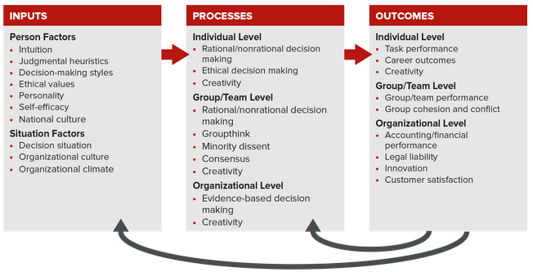



## 11.1 Rational and Nonrational Models of Decision Making

Decision making is a key process within the Organizing Framework for Understanding and Applying OB. The process varies along a continuum of rational to nonrational. Four steps in making rational decisions are (1) identify the problem, (2) generate alternative solutions, (3) evaluate alternatives and select a solution, and (4) implement and evaluate the solution. Examples of nonrational models include (1) satisficing and (2) intuition.

Decision making entails identifying and choosing from among alternate solutions that lead to a desired state of affairs. The above examples illustrate how decisions affect your chances of getting a job after graduation, but successful decision making has much broader applications. Among organizations, for example, Fortune concluded, “Decision making at even the most basic level has slowed materially over the past five to 10 years.” Slower decision-making leads to increased costs, lower efficiency, and lower customer satisfaction.12 In sum, individuals, teams, and organizations are well served to improve their decision-making skills.

Rational Decision Making: Managers Make Logical and Optimal Decisions

The rational model of decision making explains how managers should make decisions. It assumes that managers are completely objective and possess all information for their decisions. In this model, decisions thus demonstrate excellent logic and promote the organization’s best interests.

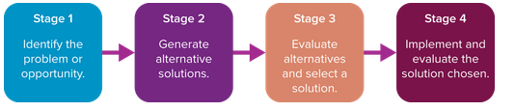

Stage 1: Identify the Problem or Opportunity, Determining the Actual versus the Desirable

We defined a problem in Chapter 1 as a difference or gap between an actual and a desired situation. By now you know that problem identification is the first step in solving any type of problem. In addition to making decisions to solve problems, however, managers also have to make decisions about optimizing opportunities. An opportunity is a situation in which results that exceed goals and expectations are possible. For example, US medical schools must prepare to produce 5,000 more graduates a year by 2019. However, this wonderful opportunity will require some tough decisions, because the number of funded residencies for medical students has been frozen since 1997. Residencies are the three to seven years of additional on-the-job training that medical students need before they can practice medicine on their own. Without more residency positions, the Association of American Medical Colleges predicts a shortage of as many as 140,000 doctors by 2025.

Stage 2: Generate Alternative Solutions, Both the Obvious and the Creative

For many people generating solutions is the exciting part of decision making, the step where you get to be creative, think outside the box, and share your ideas about how things should be done. Brainstorming, for instance, is a common technique (discussed later in the chapter) that both individuals and groups use to generate potential solutions. A research study of 400 strategic decisions revealed that managers struggled during brainstorming because of three key decision-making blunders:16

Rushing to judgment. Managers simply make decisions too quickly without considering all relevant information.

Selecting readily available ideas or solutions. Managers take the easy solution without rigorously considering alternatives. This can happen when emotions about the problem are running high.

Making poor allocation of resources to study alternate solutions. Managers don’t invest the resources to properly study the problem and the alternate courses of action.

Decision makers thus are encouraged to slow down and use System 2 thinking (analytical and conscious) when making decisions. This should lead them to identify a broader set of alternatives and potential solutions.

Stage 3: Evaluate Alternatives and Select a Solution, Ethics, Feasibility, and Effectiveness

In the third stage, evaluate your alternatives on several criteria. Costs and quality are important, but you should also consider the following questions: (1) Is it ethical? (If not, don’t consider it.) (2) Is it feasible? (If time is an issue, costs are high, resources are limited, new technology is needed, or customers are resistant, for instance, then the alternative is not feasible.) (3) Will it remove the causes and solve the problem?

Stage 4: Implement and Evaluate the Solution Chosen

After the solution has been implemented, stakeholders need to evaluate how effectively it solves the problem. If effective, it should eliminate or significantly reduce the difference between the problem state and the desired outcome. If not, either the problem was incorrectly identified or the solution was inappropriately conceived or executed. Management can return to the first step, problem identification. If the problem was correctly identified, management should consider implementing one of the untried solutions. This process can continue until all feasible solutions have been tried or the problem has changed. System 2 thinking is needed to effectively work through this stage.

What Are the Pros and Cons of the Rational Model?

The rational model is prescriptive. It outlines a logical process manager should use, assuming they are optimizing when making decisions. Optimizing means solving problems by producing the best possible solution based on a set of highly desirable conditions, having complete information, leaving emotions out of the decision-making process, honestly and accurately evaluating all alternatives, having abundant and accessible time and resources, and having people willing to implement and support decisions. Practical experience, of course, tells us that these conditions are all rarely met, and assumptions to the contrary are unrealistic. Social scientist Herbert Simon earned the 1978 Nobel Prize for his work on decision making. He put it this way: “The assumptions of perfect rationality are contrary to fact. It is not a question of approximation; they do not even remotely describe the processes that human beings use for making decisions in complex situations.”

That said, there are three benefits of trying to follow a rational process as closely as is realistically possible:

Quality. The quality of decisions may be enhanced, in the sense that they follow more logically from all available knowledge and expertise.

Transparency. Rationality makes the reasoning behind a decision transparent and available to scrutiny.

Responsibility. The rational model discourages decision makers from acting on suspect considerations (such as personal advancement or avoidance of bureaucratic embarrassment) and therefore encourages more responsible decisions.

Nonrational Models of Decision Making: Decision Making Does Not Follow an Orderly Process,

Nonrational models of decision making explain how managers actually make decisions. These models typically build on assumptions that decision making is uncertain, that decision makers do not possess complete information, and that managers struggle to make optimal decisions. The choice to text while driving is an example of nonrational decision making.

Simon’s Normative Model: “Satisfactory Is Good Enough”,

Herbert Simon proposed the normative model to describe the process that managers actually use when making decisions. This process is guided by a decision maker’s bounded rationality. Bounded rationality represents the notion that decision makers are “bounded” or restricted by a variety of constraints when making decisions. Lack of information is a prime example of a decision-making constraint. Would you invest $500 million in the face of bounded rationality? General Motors did.

In addition to lack of information, bounded rationality is caused by any personal characteristics and internal and external resources that reduce rational decision making. Personal characteristics include personality and the limited capacity of the human mind. Consider gender: Males tend to make riskier decisions than females. Examples of internal resources are the organization’s human and social capital, financial resources, technology, plant and equipment, internal processes and systems, and the time available. External resources include factors the organization cannot directly control, such as employment levels in the community, capital availability, and government policies.

Ultimately, bounded rationality leads managers to obtain manageable rather than optimal amounts of information. This practice makes it difficult for managers to identify all possible alternate solutions. In the long run, the constraints of bounded rationality cause decision makers to fail to evaluate all potential alternatives, thereby causing them to satisfice.

Satisficing consists of choosing a solution that meets some minimum qualifications and thus is “good enough.” Satisficing resolves problems by producing solutions that are satisfactory, as opposed to optimal. Finding a radio station to listen to in your car is a good example of satisficing. You cannot optimize because it is impossible to listen to all stations at the same time. You thus stop searching for a station when you find one playing a song you like or do not mind hearing.

The Intuition Model: “It Just Feels Right”,

Intuition consists of judgments, insights, or decisions that “come to mind on their own, without explicit awareness of the evoking cues and of course without explicit evaluation of the validity of these cues.” We all have the ability to use intuition.

A Model of Intuition,

A holistic hunch is a judgment based on the subconscious integration of information stored in memory. People using holistic intuition may not be able to explain why they want to make a certain decision except that the choice “feels right.” This reflects System 1 thinking (intuitive and largely unconscious).

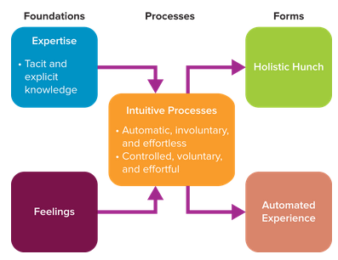

In Figure 11.3, you can see that intuition is represented by the two distinct processes we just described. One is automatic, involuntary, and mostly effortless. The second is quite the opposite in that it is controlled, voluntary, and effortful. For example, when you are trying to Page 429answer one of the Your Thoughts? questions at the end of the OB in Action boxes, an answer may pop into your mind based on your recollection of what you’ve read (an automatic process). But upon further reflection (a controlled process), you may decide your initial thought was wrong and that you need to go back and reread some material to arrive at another answer. This in turn may cause novel ideas to come to mind, and the two processes continue.

These intuitive processes are influenced by two sources: expertise and feelings (see Figure 11.3). Expertise is an individual’s combined explicit knowledge or information that can easily be put into words, and tacit knowledge or information we gain through experience that is difficult to express and formalize.

Pros and Cons of Using Intuition. There are two benefits of using intuition to make decisions. (1) It can speed up the decision-making process, which is valuable when you are under time constraints. (2) It is useful when resources are limited. On the downside, however, intuition is subject to the same types of biases associated with rational decision making, biases we discuss in the next section. In addition, the decision maker may have difficulty convincing others that the intuitive decision makes sense, so a good idea may be ignored.

## 11.2 Decision-Making Biases: Rules of Thumb or “Heuristics”,

Ever had a hard time explaining why you made a particular decision? That’s normal. All of us use shortcuts or “rules of thumb” when making decisions. Academics call these shortcuts judgmental heuristics, pronounced “hyur-ris-tiks.” Judgmental heuristics are cognitive shortcuts or biases that are used to simplify the process of making decisions.

Availability bias. The availability heuristic is a decision maker’s tendency to base decisions on information readily available in memory. Because the information is recent, we overestimate its importance. The problem, of course, is that recent information is not necessarily the best or most accurate. The availability bias can be fueled by news media, which emphasize negative or unusual events like plane crashes and high-school shootings and often cause us to overestimate their frequency.

Hindsight bias. Imagine you are taking an OB course that meets Tuesdays and Thursdays, and your professor gives unannounced quizzes each week. It’s the Monday before a class, and you are deciding whether to study for a potential quiz or watch Monday Night Football. Two of your classmates have decided to watch Page 434the game rather than study because they don’t think there will be a quiz the next day. The next morning you walk into class and the professor says, “Take out a sheet of paper for the quiz.” You turn to your friends and say, “I knew we were going to have a quiz; why did I listen to you?” Hindsight bias occurs when knowledge of an outcome influences our belief about the probability that we could have predicted the outcome earlier. The danger of this bias is that, in retrospect, we get overconfident about our foresight, which leads to bad decisions. For example, investors prone to this bias will confidently think they are predicting good investment opportunities on the basis of such experiences, only to find out that they invested in dogs.

Framing bias. Framing bias relates to the manner in which a question is posed or framed. It leads us to change the way we interpret alternatives. For example, customers have been found to prefer meat that is framed as “percent lean” instead of “15 percent fat,” although, of course, the two mean the same thing. In general, people view choices more favorably when they are framed in terms of gains rather than loses. You would be more likely to invest in a product that had a 60 percent chance of success rather than a 40 percent chance of failure. Try framing your decision questions in alternate ways to avoid this bias.

Escalation of commitment bias. Escalation of commitment bias is the tendency to hold to an ineffective course of action even when it is unlikely the bad situation can be reversed. Would you invest more money in an old or broken car? The Drug Enforcement Administration and the Pentagon continued to spend on a spy plane for use in Afghanistan that was supposed to be completed in 2012 at a cost of $22 million, even though the project had missed every projected delivery date. In March 2016, it had not yet left the ground, and total payouts had reached $86 million.

Researchers recommend the following actions to reduce the escalation of commitment:

Set minimum targets for performance, and have decision makers compare their performance against these targets.

Regularly rotate managers in key positions throughout a project.

Encourage decision makers to become less ego-involved with a project.

Make decision makers aware of the costs of persistence.

TAKE-AWAY APPLICATION,

Reducing My Use of Decision-Making Biases,

Using the list of decision-making biases, consider the following:

Think of a poor decision you made in the past 6 to 12 months.

Which of the eight decision-making biases may have influenced your decision?

Based on your answer and your knowledge of judgmental heuristics, what could you have done differently to avoid the poor decision?

## 11.3 Evidence-Based Decision Making,

Evidence-based decision making is the process of conscientiously using the best available data and evidence when making managerial decisions. It holds the promise of helping avoid the decision-making biases discussed above and improving performance while reducing costs. Proponents also believe evidence-based decision making can help in the use of “big data” to market and sell products and services.

Using Evidence to Make Decisions

Managers use evidence or data in three different ways: to make a decision, to inform a decision, and to support a decision. Here is what a team of researchers had to say about how we use data to make decisions.

“Evidence is used to make a decision whenever the decision follows directly from the evidence.” For example, if you wanted to purchase a particular used car such as a Toyota Prius based on price and color, you would obtain data from the Internet and classified ads and then choose the seller offering the lowest-priced red Prius. “Evidence is used to inform a decision whenever the decision process combines hard, objective facts with qualitative inputs, such as intuition or bargaining with stakeholders.” For instance, when firms are hiring new college graduates, objective data about their past experience, education, and participation in student organizations is relevant input to the hiring decision. Page 437Nonetheless, subjective impressions garnered from interviews and references are typically combined with these objective data to make a final decision. These two uses of evidence are clearly positive and should be encouraged. The same cannot be said about using evidence to support a decision.

“Evidence is used to support a decision whenever the evidence is gathered or modified for the sole purpose of lending legitimacy to a decision that has already been made.” This application of evidence has both positive and negative effects. On the positive side, evidence collected after the fact can be used to convince an external audience that the organization is following a sound course of action in a complex and ambiguous decision context. This can lead to confidence and goodwill about how a company is responding to environmental events. On the negative side, the practice can stifle employee involvement and input because people will come to believe that management is going to ignore evidence and just do what it wants. In summary, because this practice has both pros and cons, management needs to carefully consider when (if ever) it might be appropriate to ignore disconfirming evidence and push its own agenda or decisions.

Big Data: The Next Frontier in Evidence-Based Decision Making,

Managers and companies that effectively utilize big data, such as Kroger (see the Problem-Solving Application box), are expected to gain competitive advantage. Big data creates value in the following ways:

It can make information more transparent and usable.

It allows organizations, like Kroger, to measure and collect all types of performance information, enabling them to implement initiatives to enhance productivity.

It allows more narrow segmentation of customers.

## 11.4 Four Decision-Making Styles,

We make countless decisions on a daily basis, what to wear, what to eat, what route to take driving to school, whether to confront a negative colleague. These decisions are guided by our decision-making style. A decision-making style is the way an individual perceives and comprehends stimuli and the general manner in which he or she chooses to respond to such information. A team of researchers developed a model of decision-making styles based on the idea that styles vary along two dimensions: value orientation and tolerance for ambiguity.

Value Orientation and Tolerance for Ambiguity

Value orientation is the extent to which an individual focus on either task and technical concerns or people and social concerns when making decisions. Some people, for instance, are very task-focused at work and do not pay much attention to people issues, whereas others are just the opposite.

The second dimension pertains to a person’s tolerance for ambiguity. This characteristic indicates the extent to which a person needs structure or control in his or her life. Some people desire a lot of structure. They have a low tolerance for ambiguity and find ambiguous situations stressful and psychologically uncomfortable. Others do not have a high need for structure and can thrive in uncertain situations; their tolerance for ambiguity is high. Imagine the ambiguity faced by Andrés Sepúlveda as he worked to rig political campaigns across Latin America. He and his team of hackers “stole campaign strategies, manipulated social media to create false waves of enthusiasm and derision, and installed spyware in oppositions offices, all to help Peña Nieto get elected president of Mexico,” according to Bloomberg Businessweek. Ambiguous situations can energize people like Sepúlveda with a high tolerance for ambiguity.

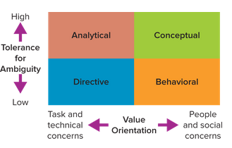

The Directive Style: Action-Oriented Decision Makers Who Focus on Facts

People with a directive style have a low tolerance for ambiguity and are oriented toward task and technical concerns when making decisions. They are efficient, logical, practical, Page 440and systematic in their approach to solving problems. Directive decision makers are action oriented and decisive and like to focus on facts. In their pursuit of speed and results, however, they tend to be autocratic, exercise power and control, and focus on the short run.

The Analytical Style: Careful and Slow Decision Makers Who Like Lots of Information,

People with the analytical style have a much higher tolerance for ambiguity and tend to overanalyze a situation. They like to consider more information and alternatives than do those with a directive style. Analytical individuals are careful decision makers who take longer to make decisions but who also respond well to new or uncertain situations. They can often be autocratic.

The Conceptual Style: Intuitive Decision Makers Who Involve Others in Long-Term Thinking

People with a conceptual style have a high tolerance for ambiguity and tend to focus on the people or social aspects of a work situation. They take a broad perspective on problem solving and like to consider many options and future possibilities. Conceptual types adopt a long-term view and rely on intuition and discussions with others to acquire information. They also are willing to take risks and are good at finding creative solutions to problems. On the downside, however, a conceptual style can foster an idealistic and indecisive approach to decision making.

The Behavioral Style: Highly People-Oriented Decision Makers

The behavioral style is the most people-oriented of the four. People with this style work well with others and enjoy social interactions in which opinions are openly exchanged. Behavioral decision makers are supportive, are receptive to suggestions, show warmth, and prefer verbal to written information. Although they like to hold meetings, they prefer to avoid conflict and can be too concerned about others. This can lead behavioral types to adopt a conflict-avoidance approach to decision making and to have a hard time saying no.

## 11.5 A Road Map to Ethical Decision Making

A decision tree is a graphical representation of the process underlying decisions, and it shows the consequences of making various choices. You can follow Bagley’s decision tree, shown in Figure 11.5, by asking the following questions about your decision:

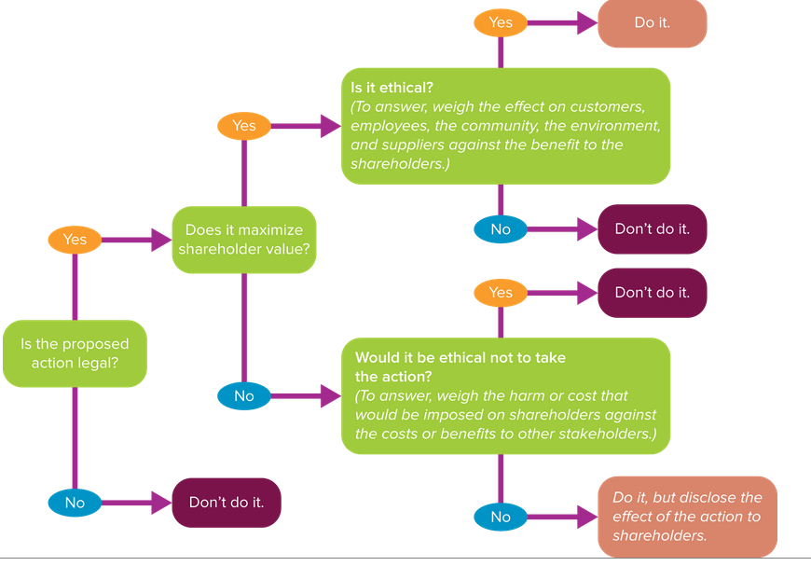

(1) Is the proposed action legal? This may seem like a common-sense question, but some managers and companies fail to ask it. Synthes, a medical device maker, decided to market Norian XR, a cement that can turn into bone when injected into humans, for spine surgeries, despite being told not to by the Food and Drug Administration. At least five people died on the operating table after being injected with Norian.

(2) If “yes,” does the proposed action maximize shareholder value? A decision maximizes shareholder value when it increases profits for an organization, because these profits are eventually distributed to shareholders. Regardless of shareholder value, however, the decision tree shows that managers still need to consider the ethical implications of each decision or action.

(3) If the decision maximizes shareholder value, the decision maker than considers whether or not the action is ethical. Managers should answer this question by weighing the effect of the action on an organization’s other key constituents (customers, employees, the community, the environment, suppliers) against the benefit to the shareholders. For example, Bangladesh factory owners bullied employees to work in a building despite warnings from engineers that an exterior crack made it unsafe. They did this out of fear of losing business, which would have had a negative impact on shareholder value. In 2013 the building collapsed, killing 1,129 people. The decision to force workers to enter may have benefited shareholders, but it was a tragically poor choice for employees and for the country. Obviously, then, it was also unethical.

(4) If the decision does not maximize shareholder value, then the decision maker should consider whether it would be ethical not to take the proposed action. If an action would not directly benefit shareholders, consider whether it would be ethical not to take it. The decision to continue operating factories in the damaged building in Bangladesh was harmful to other stakeholders, employees and the country. The ethical decision might have been to ask employees to enter the building only after the structural problems had been fixed, and to ask customers for some leeway in filling orders.

## 11.6 Group Decision Making,

Advantages and Disadvantages of Group Decision Making,

Advantages

These five advantages are most likely to be found when the group has experience with the issue at hand, and when it is diverse in terms of characteristics such as personalities, gender, attitudes, and experience.

Greater pool of knowledge. A group possesses more information and knowledge than one individual acting alone.

Different approaches to a problem. Individuals with different backgrounds and experiences bring varied perspectives to diagnosing and solving problems.

Greater commitment to a decision. Participation and a voice in decision making are more likely to result in commitment to a decision. This in turn leads group members to accept and feel responsible for implementing a proposed solution.

Better understanding of decision rationale. Participating in a decision increases group members’ understanding about why the decision is being made and what must occur to implement it. This in turn reduces miscommunication among people.

Disadvantages

The disadvantages of group-aided decision making relate to group dynamics and interpersonal interactions.

Social pressure. The desire to look good in front of others, particularly the boss, leads to conformity and stifles creativity.

A few dominant participants. The quality of a group’s decision can be influenced by a few vocal people who dominate the discussion. This is particularly problematic when the vocal person is perceived as a powerful individual.

Goal displacement. When the group is evaluating alternatives, secondary considerations such as winning an argument, getting back at a rival, or trying to impress the boss can override the primary goal of solving a problem. Goal displacement occurs when the primary goal is overridden by a secondary goal.

Groupthink,

As you might imagine, groupthink negatively affects group performance and is often driven by high levels of cohesiveness. Cohesiveness or a sense of “we-ness” tends to override individual differences and motives. Members of groups tend to be cohesive for two fundamental reasons: (1) they like and enjoy each other’s company and (2) they need each other to achieve a common goal. You can see how cohesiveness is a double-edged sword in its effects on group-level outcomes in the Organizing Framework. It can help you and your team reduce conflict, but it can also reduce performance if it limits questioning and critical thinking and results in groupthink. How do you avoid groupthink? First, know the symptoms.

Symptoms of Groupthink

There are eight common symptoms of groupthink. The more that are present in a situation, the higher the probability that groupthink will occur.

1. Invulnerability. An illusion that the group cannot make a mistake breeds excessive optimism and risk taking.
2. Inherent morality. Assuming the group is highly moral encourages members to ignore ethical implications.
3. Rationalization. Members protect their personal or “pet” ideas and assumptions.
4. Stereotyped views of opposition. The group may underestimate opponents.
5. Self-censorship. Keeping ideas and questions to yourself stifles critical debate.
6. Illusion of unanimity. Members’ silence can be interpreted to mean consent.
7. Peer pressure. Be careful when the loyalty of dissenters is questioned.

Prevention Is Better than Treatment,

Prevention is better than treatment or cure when dealing with groupthink. Table 11.1 provides excellent recommendations for removing barriers to minority dissent. Minority dissent occurs when group members feel comfortable disagreeing with other group members. Research reveals that minority dissent is positively related to participation in decision making and job satisfaction.

Reaching Consensus: The Goal of Group Problem-Solving Techniques,

Groups asked to make decisions must generally reach a consensus. According to a decision-making expert, a consensus “is reached when all members can say they either agree with the decision or have had their ‘day in court’ and were unable to convince the others of their viewpoint. In the final analysis, everyone agrees to support the outcome.” This definition indicates that consensus does not require unanimous agreement, because group members may still disagree with the final decision but are willing to work toward its success. They must honestly and accurately communicate with each other when trying to reach a consensus.

Brainstorming: A Tool for Generating Ideas,

Brainstorming helps groups generate multiple ideas and alternatives for solving problems. Developed by advertising executive A. F. Osborn, brainstorming can apply in a variety of contexts. They include solving problems, developing creative ideas for new products, removing performance roadblocks, and developing action plans to achieve goals. Brainstorming sessions begin by asking participants to silently generate ideas or solutions, which then are collected either in public or anonymously and summarized in some fashion (such as on a whiteboard or a flip chart).

At a second session group members critique and evaluate the alternatives. Today, many brainstorming sessions are conducted electronically. Electronic brainstorming, sometimes called brainwriting, allows participants to submit their ideas and alternatives over a computer network. Webinars work well for this purpose.

The Delphi Technique,

The Delphi technique was originally developed by the RAND Corp. for technological forecasting. It now serves as a multipurpose planning tool. The Delphi technique is a group process that generates anonymous ideas or judgments from physically dispersed experts in multiple rounds of brainstorming.

Decision Support Systems,

The increased globalization of organizations, the existence of big data, and the advancement of information technology have led to the development of decision support systems. Decision support systems (DSS) are “computer-based interactive systems that help decision makers to use data and models to solve unstructured problems.” For example, Best Buy, Google, GE, Intel, and Microsoft all use internal intranets to obtain input for their DSS from employees. Both Best Buy and Google found DSS systems helpful in estimating the demand for new products and services. They also improve information processing and decision making within virtual teams.

## 11.7 Creativity,

Creativity is defined here as the process of producing “new and useful ideas concerning products, services, processes, and procedures.” Being creative can be as simple as locating a new place to hang your car keys or as complex as developing a pocket-size microcomputer. You can create something new, combine or synthesize existing things, or improve or change things.

A Model of Creativity,

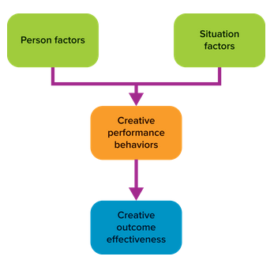

Creative Performance Behaviors Produce Creative Outcome Effectiveness

Creative performance behaviors are four key behaviors that drive the production of creative outcomes. Creative outcome effectiveness is “the joint novelty and usefulness (quality) of a product or service” as judged by others.

Problem formulation/definition. Problem formulation is the familiar Step 1 in our 3-Step Problem-Solving Approach. The practice of accurately defining the problem will enhance your creativity, and it requires System 1 thinking (System 1 thinking is intuitive and mainly unconscious).

Preparation/information gathering. The preparation stage reflects the notion that creativity starts from a base of knowledge. Experts suggest that creativity arises from the convergence of tacit and explicit knowledge. Lowell Wood, the most prolific inventor in U.S. history, he holds 1,085 patents, one more than Thomas Alva Edison, is inventor in residence at Intellectual Ventures.

Example. Wood is an astrophysicist, a self-taught paleontologist, and a computer scientist. He works hard at being creative. In commenting about his time studying in college and graduate school, he told a writer from Bloomberg Businessweek that he “often failed or received the lowest score on the first exam given in a particular course and improved his marks through repetition and intense effort.” He credits his ability to find creative solutions to problems to the amount of reading he does. He religiously reads three dozen academic journals from varying fields of study. He got this habit from chemist and author Linus Pauling. Wood asked Pauling how he comes up with all his great ideas. Pauling said, “There’s really nothing to it all. You just read, and you remember what you read.

As Lowell Wood’s career demonstrates, preparation/information gathering consists of intentionally and actively searching for new information related to a problem.

Idea generation. Generating ideas requires making new mental connections about the task or problem at hand. This behavior is emphasized in brainstorming and calls for System 1 thinking.

Idea evaluation/validation. Selecting the most creative and promising idea from among multiple options relies on System 2 thinking (System 2 thinking is analytical and mainly conscious).

Practical Recommendations for Increasing Creativity

While some consultants recommend hypnotism as a good way to increase employees’ creativity, we prefer suggestions derived from research and practical experience. The first recommendation is to effectively manage the four creative performance behaviors. Another is to allow yourself to enjoy boredom. According to experts, “when we experience boredom, two areas of the brain may be busy working closely together, the executive network, which solves problems, and the so-called default network, which takes over when your brain isn’t involved with something external. The result is enhanced creativity.” This suggests that doing “nothing,” such as “just sitting in a café, strolling in the park, lying on the beach, or even staring into space while everyone else is running busily, may be one of the most important creative things we can do,” according to management expert Manfred Kets de Vries. Research also has uncovered some practical tips that all of us can use to increase our creativity.